PRESS KIT

“…when one door is closed//many more are open…”
Challenger – Give It A Try

Artist Biography

Born on the island of Dominica in the Caribbean, Challenger was surrounded by the ever pulsating tunes of calypso, soca, reggae, and the music rooted from the island itself, bouyon; a style of music that blends all of the music from the Caribbean.
For twelve years after migrating to the USA, Challenger was lead vocalist and song writer of a Caribbean fusion band named Royalty Band, entertaining crowds with his electrifying voice. After performing at small private events Challenger and the Royalty Band started showing off their musical skills at many Caribbean festivals throughout the US, Canada and on islands like Tortola, St. Thomas and his homeland Dominica.
But to Challenger, reggae music was the vehicle to root his message about peace, love and world unity, and to bring light to everyday struggles. In January, 2015, he released his first EP, Man Is Just a Man. Challenger is currently working on his first reggae album and staging at several venues on the east coast alongside his band, The KingsGuard.
Challenger headlined this year’s LTC Industry Mixer at Suite 36 and will be the only reggae act at their Christmas event at The High Line Ballroom in NYC. The artist ended the Caribbean Jerk Festival at The Hall in Brooklyn performing two consecutive nights, closing off the event with much “fyah”.
In October 2016, Challenger released his first ever music video “Jah Walk with Me” via ReggeaVille and keeps receiving a remarkable response as his views continue to soar. The artist is currently working with several music producers - Obanga Productionz, S.D.R.G, Dirty Frequency, Otis Riddim Records, Andrew Robinson A.R.W.M Swiss/Jam Records & Izrah Music, and also with a video and production team to produce two music videos.
In December Challenger and his band KingsGuard got a great reception at the Highline Ballroom in NYC and in January plan to perform an amazing show at The Knitting Factory in Brooklyn NYC. He looks forward to the many shows he will be featured in will continue to evolve and bring back the much needed vibe in the industry, with his music.

Artist Photos

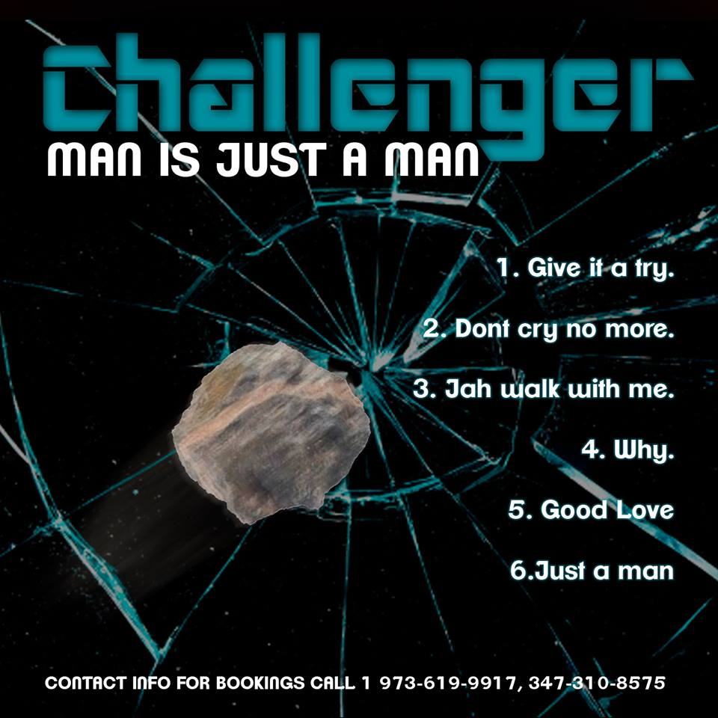

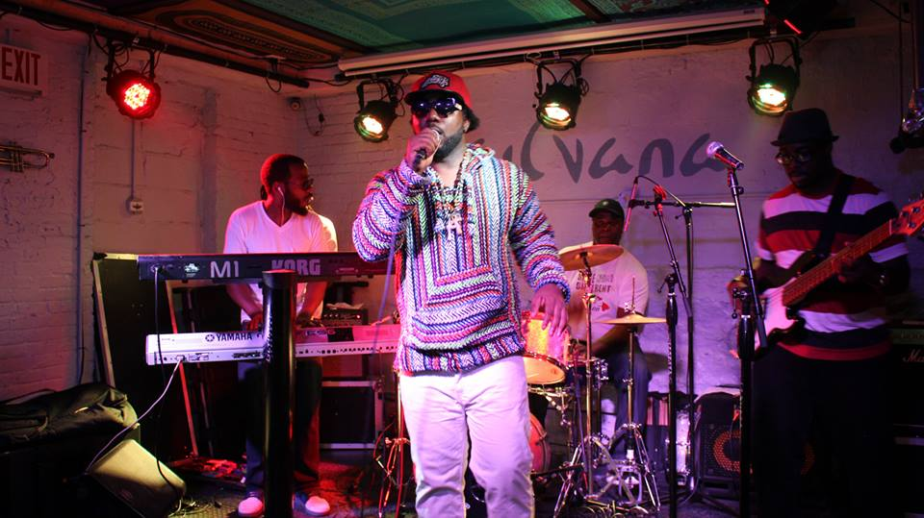
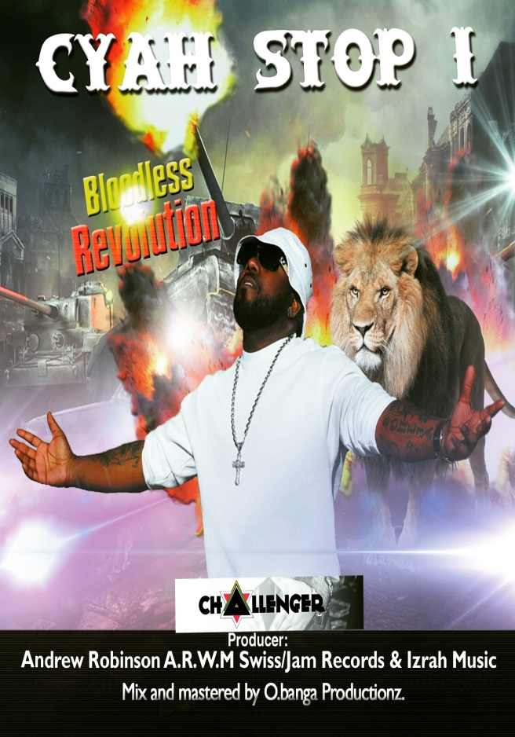

Media Links
FaceBook: https://www.facebook.com/challengermusic1
SoundCloud: https://www.soundcloud.com/challengerreggae
YouTube: https://www.tinyurl.com/challengermusic
InstaGram: https://www.instagram.com/challengermusic
Artist Reel
YouTube: https://www.youtu.be/367593glves
Music Video
https://reggaeville.com/artist-details/reggaeville/videos/video/challenger-jah-walk-with-me

Online Shops
Spotify:
https://play.spotify.com/album/7djBeuNYTu7LTt31uq8D5V?play=true&utm_source=open.spotify.com&utm_medium=open
Amazon:
https://www.amazon.com/gp/product/B00SIJAH6C?ie=UTF8&keywords=challenger%20man%20is%20just%20a%20man&qid=1453837893&ref_=sr_1_1&sr=8-1
CD Baby: https://www.cdbaby.com/cd/challenger1
Groove Music:
https://music.microsoft.com/album/challenger/man-is-just-a-man/bz.0EE6C208-0100-11DB-89CA-0019B92A3933?target=web
GoogleMusic: https://play.google.com/store/music/album/Challenger_Man_Is_Just_a_Man?id=Bjp34olp6tbejryvcmx2r7t6bqq
iTunes: https://itunes.apple.com/us/album/man-is-just-a-man-ep/id959754465

Bookings & Info
management@challengermusic.net
lolacgrove@gmail.com
grichards251@gmail.com
347.623.1875
347.310.8575
973.494.6249

